OFFICIAL RULES FOR Homestead

Players: 2-6 players
Deck Size: >60 cards per player or one central deck >100 cards

Objective
The objective of Homestead is to complete a homestead or house by purchasing furniture, electronics, appliances and other necessities. Depending on the length of game desired, you can change the required number of items per room using the chart on page 10. After a player goes out and scores the going-out bonus, the value of each player’s house is added up. The player with the most expensive house wins.

Rooms
The six major rooms required are the Dining Room (where tables, chairs, curios and chandeliers, etc. are placed), the Living Room (where couches, comfy chairs, televisions, radios, VCRs, end tables, coffee tables, etc. are placed), the Kitchen (where stoves, ovens, microwaves, refrigerators, sinks, etc. are placed), the Bathroom (where toilets, tubs, sinks, showers, etc. are placed), the Bedroom (where beds, nightstands, dressers, chests of drawers, etc. are placed), and the Office (where desks, computers, filing cabinets, etc. are placed). There are also other rooms where items can be placed. These are defined on the cards. Cards in one room should be grouped together in separate piles to represent the separate rooms.

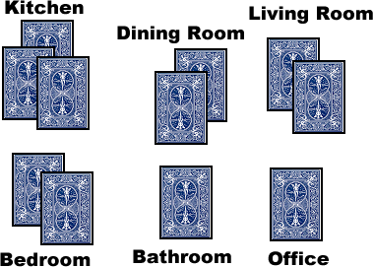

Figure 1: A Basic Setup of the rooms with their contents separated.

Card Types

Career Track
How do you buy these items to put in the homestead? You have to get a job. Each deck needs to have at least one career card. You are allowed to search your deck for any career card with a Promotion Level (PL) of 1 and place it in play before shuffling the deck to play. This allows everyone to start with an entry-level job. You will need to acquire skills to advance to better, higher-paying jobs. Sometimes a career card will list multiple salaries and promotion ranks and is titled a “Career Track”. This one card can be used to progress through several promotions, each increasing your pay.
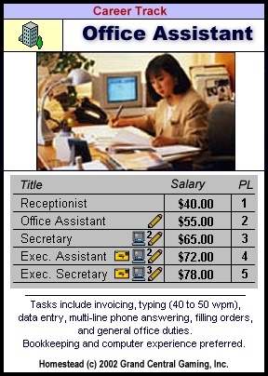

Career
There are also regular careers. Sometimes single careers mirror a career on a Career Track card but pay more in salary. The better jobs are usually individual cards and are not on a career track. Each career has a Title, and Industry, a PL, a Salary and some flavor text. Some Career cards also include a bonus. Only Career cards have special bonuses while Career Track cards cannot.

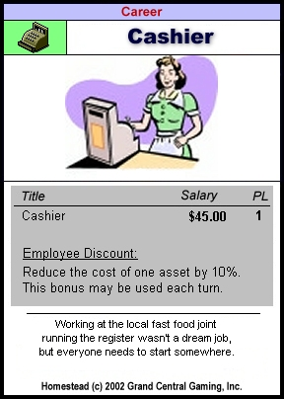

Asset
This is the stuff you put in your house. Each asset has a location, a price and a bonus. Some also have an upkeep cost. This is the price paid per turn to keep the asset in running condition.

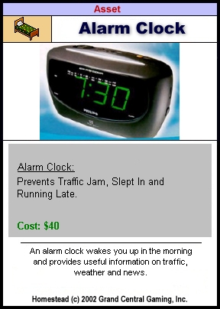

Bonus!
This is a card that can be played when specified on the card to provide a bonus. Some of these can be played on other players as well. Some bonuses affect the entire game and some affect individuals.

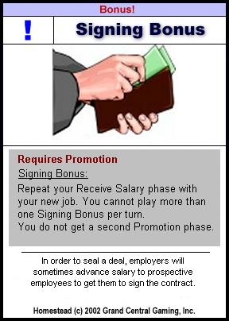

Zinger!
This is a card that is usually played against your opponent and causes an obstacle to be placed in their path or causes other undesirable effects. Some Zingers! require a condition to be met before they can be played.

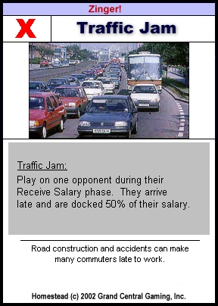

Sequence of Play

- Check Victory Conditions
- Receive Salary
- Promotion
- Shopping
- End Turn

Check Victory Conditions
This is the first phase of the turn. You check against the following chart to see if you have won.

Type of Game | Rooms | Items per Room | All Required Assets
Short | 4  no Bathroom or Office | 4 | No
Medium | 5  no Office | 6 | Yes
Long / Tournament | 6 | 8 | Yes

Receive Salary
During this phase, you collect your current salary stated on your active Career or Career Track card. If you have no Career card for any reason, you collect $20 unemployment during this phase.

Promotion
If you want to change jobs or advance on a Career Track, it is done in the Promotion phase. If you have a Career card in play or in your hand of the same industry, you may be promoted to a PL one greater than your current position. If you are switching industries, you may not increase your PL. You may always play a Career card with a lower PL than your current PL. A Career Track may be played if one of the level’s PL is lower than or equal to your current PL. If you also match the skills required for the Career, you may be promoted to that career. Flip all other Career cards or Tracks facedown to show they are inactive and leave the new Career face-up to show it is the active Career.

Shopping
This is the phase where you buy assets to populate your house.

