

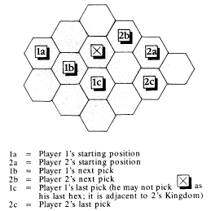
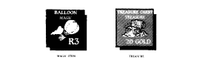
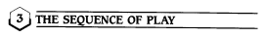

(2.15) Starting Positions: There are four possible places to start your kingdom, as shown in the previous illustration. Each player rolls two dice. The high roller chooses a starting position first (he’s now the first player), followed by the other players in clockwise order (you may have to shift seats when you’re through, so don’t get comfortable). The final arrangement of seats, clockwise from thc first player, is known as the player order Now you can turn those hexes lace-up.

Note: If your starting position is a sea hex or is adjacent to two or more sea hexes, you may remove the sea hex(es) and replace it with a hex drawn from the deck. Repeat this process until your starting position is land with at least two land hexes adjacent to it.

(2.16) Starting Kingdoms: Each player receives a set of control markers from the bank and places one marker in his starting hex to show that he owns it. Then, in player order, each player selects and marks a second hex. Repeat this procedure one more time so that each player has a kingdom consisting of three hexes. A player’s second and third hex must be adjacent to at least one of his previous hexes, and may not be adjacent to the hex of another player.

(2.17) Starting Forces: Next, each player takes 10 gold pieces (see Section 5) and one tower from the bank, and a rack. In player order, each player takes his tower and puts it in one of his hexes.

Then, again in player order, each player draws 10 Things from the cup (at random - no peeking!). In player order, each minor noble may place some or all of his Things on the board:

* Special income counters include cities, villages, and other counters keyed to specific terrain and printed with gold values. You can place one (and only one) special income counter in each hex you own. Villages and cities can be placed in any of your hexes. Other special income counters can only be placed in hexes of their terrain type.

Example: The Elephants’ Graveyard counter says Jungle. If you have a jungle hex, you may place the graveyard there: if you don’t you can’t place the graveyard on the board.

* Creature counters include killer racoons, ice worms, and other various critters that populate Kadab, You can place your creature counters in any hexes you own, up to 10 per hex. Place them face down and make neat little stacks in whatever hexes you put them.

* Magic items and treasures (along with any other unplayed Things) are placed in your rack.

(2.18) Exchanging Things: Next, in player order, players who still have Things on their racks can turn them in for new ones. A player gets to draw one new counter for each counter he returns to the cup. Decide what Things you will return; then draw replacements; then put the returned counters into the cup. If you don’t like your replacement counters, tough - you can’t replace them again.

Again in player order, anyone who drew replacement counters can place them on the board, according to the rules in 2.17. The rest are placed on the racks.

(2.19) Preparing the Deck: Shuffle all the unused terrain hexes together with the four sea hexes set aside earlier. Keep this deck face down and set it near the bank.

(2.2) Two or Three Players
In a two or three player game, the board is smaller; see Section 16.
Kings & Things * is played in turns; each turn is divided into phases.

(3.1) The First Player
During set-up, a player order was determined (see Section 2.15). During each phase, the players perform actions in order.

