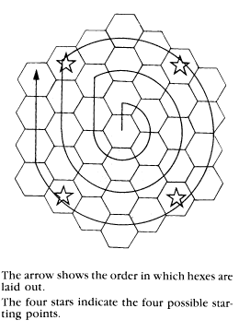


The 234 counters with the blank backs are called Things. They represent the fantastic creatures, special income counters, magic items, treasures, gold and random events in the world of Kings and Things*. The remaining counters - all with variously marked backs - are forts (in four sizes), control markers (used to denote ownership of land hex tiles and Thing stacks), and special characters (the powerful heroes of the world).
Kadab (by conquering it yourself, of course), there are a couple of things you should know and do. Kings & Things works best with four players, but if you can’t find that many minor nobles, even two or three players will find the game fun and exciting.

There are a number of tasks that need to be done to set up the game. They are:
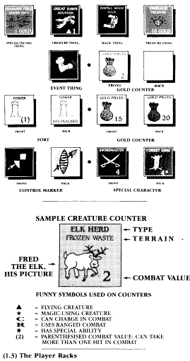
(2.11) The Bank: This is where all those important game pieces are kept so they are easily accessible throughout the game. Sort the forts, gold pieces and control markers by type. Set them off to one side of the playing area.

(2.12) The Playing Cup: This is what you will randomly draw Things from. Place all of the Thing counters in a large cup, bowl, or even the box top (see. every component has an important function). Mix well. Oh, don’t forget to punch them out first.

(2.13) Special Characters: Randomly determine which side of the back-printed special character counters will be used in the game. Some acceptable methods to do this are: (1) toss them from a cup or your hand and see which side they fall on, or (2) roll a die for each counter: 1 - 3 = front. 4 - 6 = back. Set them near the bank.

(2.14) Hex Tile Set-up: Now its time to see exactly what the Big Boom is doing to the Kadab terrain this week. Set aside four of the eight sea hexes (short for hex tiles). Then shuffle all the land and four remaining sea hexes together face down into a large deck. Now lay out the hoard according to the diagram in the illustration below. Don't turn the hexes face-up yet.

The racks are used to hold Things not currently in use and to keep them secret from the other players. Treasures, events, magic items, special income counters and creatures can all he kept on your nifty thingamajigs. Special characters, gold counters, and forts may never be placed on them.

(2.1) The Standard Four Player Game

Before you can set out to reunite the shattered kingdom of

