Note: A few creatures have combat values of six. These hit automatically, but the die must still be rolled. (The Talisman or Black Cloud could affect these creatures and their rolls).
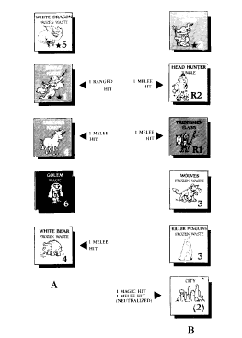
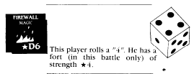

* Forts, cities and villages have combat values equal to their current level (For example, a city which has taken one hit has a combat value of 1). See Section 12.

Player A rolls a 3 and a 2 in the magic step, Player B rolls a 4. Player A scores one hit, which Player B takes from the City.

Player B rolls a 4 and a 1 in the ranged step, for one hit. Player A removes the * 1 creature.

In melee, Player A rolls a 4, 4, 4, scoring 3 hits. Player B rolls a 2, 2, 2, scoring only 2 hits (the city was reduced to a combat value of 1). Losses are taken as shown. Player A retreats.

(11.5) Applying Hits

During a Combat Step, you and your opponent roll for all creatures which can fight in that step, before either side suffers any losses. After losses are applied the next step begins.

Example: During the Magic Combat Step, all of your magic creatures roll, and so do your opponents. If hits are inflicted, they are applied after all magic creature die-rolls, but before moving to the Ranged Combat Step. If you choose to apply a hit to a ranged creature it is returned to the cup and won’t get to fight in the Ranged Step.
(11.51) After the number of hits your forces suffer has been determined, you decide which of your counters are damaged or removed.

(11.52) If a creature or special character (except the Sword Master, see the pull-out) takes a hit it is eliminated. A fort, village or city can take as many hits as its combat value. If it takes that many it is neutralized. If it takes fewer hits, mark the counter with a gold piece or a die showing the number of hits it has taken.

(11.53) When a counter is neutralized, flip it over. It is not destroyed, but it can no longer participate in the battle.

* Forts, villages and cities which take fewer hits than their
combat value continue to fight, but at their reduced strength.
Castles and citadels do not lose their R and * status.
* See Section 12 for more details about forts in combat.

(11.6) Retreats

Is the fight going badly? Did the hex you decided to liberate from your opponent contain one surprise too many? Well, discretion is the better part of violence, or something like that.

At the end of each combat round, the attacker (the player who doesn’t own the hex) has the option to retreat, ending the battle. If the attacker decides to stay and fight, then the defender (the owner of the hex) has the option to retreat.

To retreat, move your counters to an adjacent hex you control which is not currently occupied by enemy counters. If no such hex exists, your force may not retreat; it must stay and fight.

When a force retreats, all friendly creatures and special characters in the battle hex must retreat together into the same hex. If that hex then contains more than 10 friendly creatures, the excess are removed (see 9.2).

If there are more than two players involved in the same battle, see 11.8.

Note: Only creatures and special characters may retreat; forts and special income counters must be left behind. They may continue to fight alone if they have not been neutralized.
* The defenders of a previously unexplored hex may not retreat.

(11.7) Post-Combat

What happens once the dust settles over the battlefield and the combat is decided? Well, after all but one side has been eliminated or forced to retreat, ownership of the hex and the status of the forts, cities, villages, and other special income counters must be determined.

(11.71) If all attacking counters are eliminated or forced to retreat, the hex remains the property of the defender, even if all defending counters were eliminated or neutralized.

